WEEK 6 PRACTICAL
QUESTION 1
Create a client-server application using Named Pipes (FIFOs). The client sends messages and the server processes and responds to them. Analyze FIFO behavior when multiple clients communicate simultaneously.
Aim
To implement client-server communication using Named Pipes (FIFOs), where clients send messages to a server and the server processes and responds to them.
Program — Server (server.c)
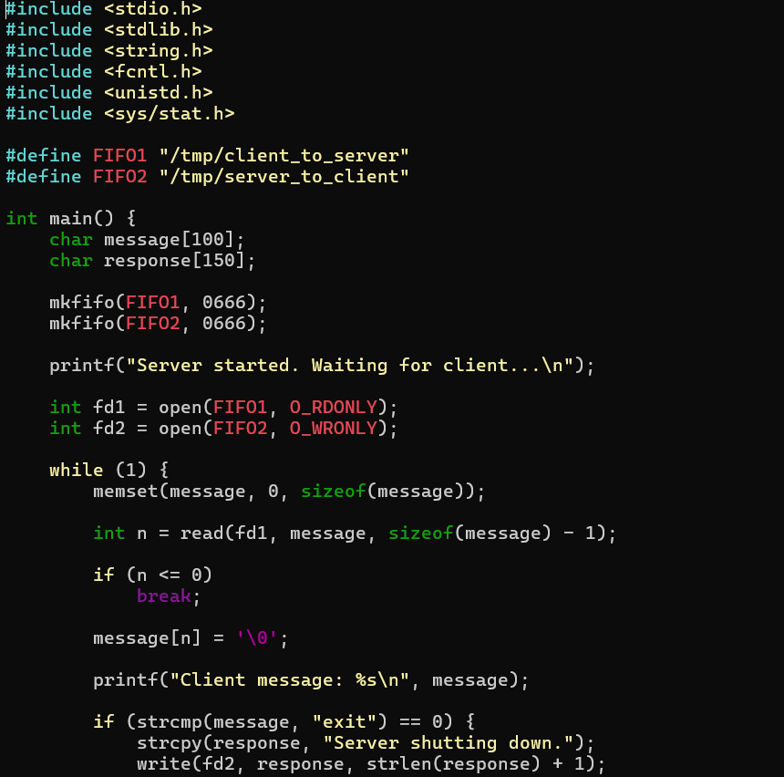

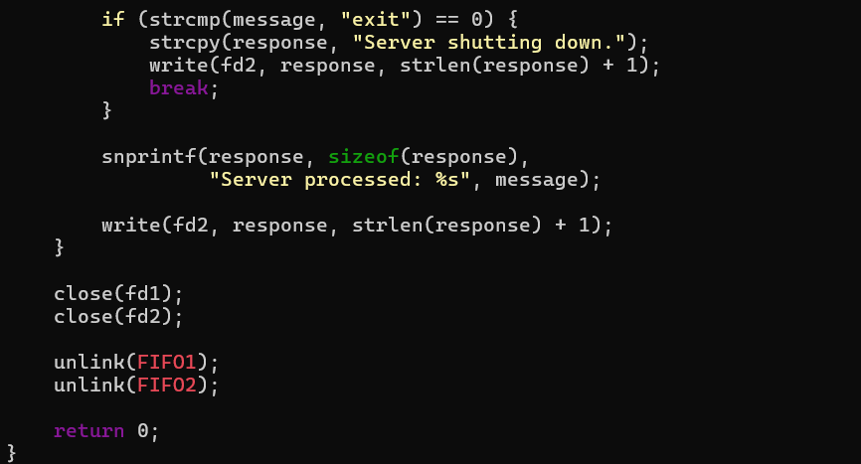

Program — Client (client.c)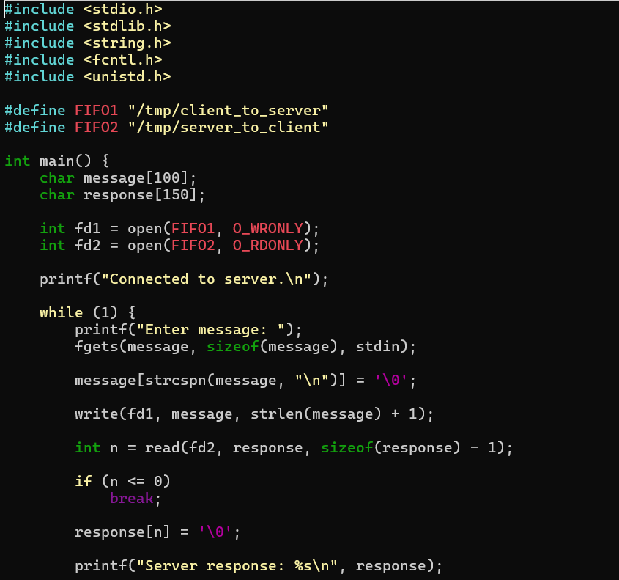
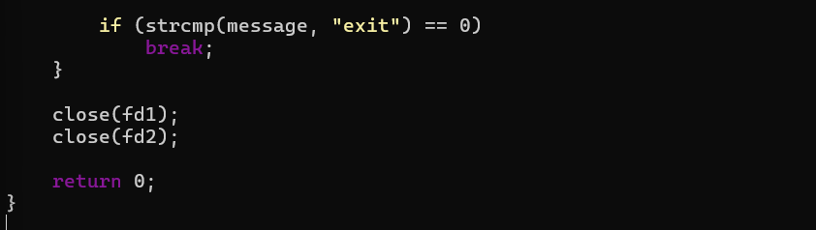

Output
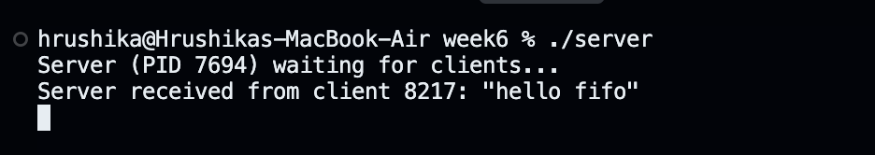
Terminal 1 — Server

Terminal 2 — Client
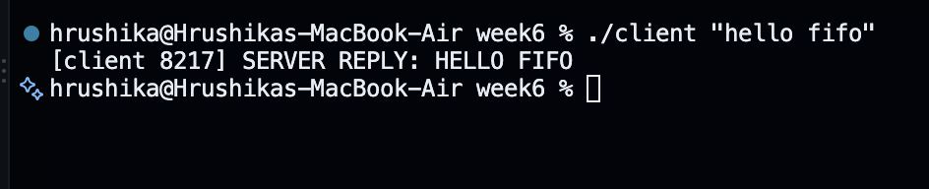

Observation
The named FIFOs provide communication between processes without requiring them to be related by fork(). The client writes messages to the client-to-server FIFO, while the server reads and processes them and sends responses through the server-to-client FIFO.
When multiple clients communicate simultaneously, messages are placed into the FIFO according to the order in which writes occur. A single FIFO does not automatically provide separate communication channels for individual clients, so a practical multi-client server would normally use separate response FIFOs or another mechanism to identify each client.
Result
The client-server communication system was successfully implemented using Named Pipes (FIFOs), and the behavior of FIFO communication with multiple clients was analyzed.

QUESTION 2
Create a POSIX signal handling program that captures SIGINT, SIGTERM, and SIGUSR1. Demonstrate asynchronous event handling and explain the role of signal handlers.
Aim
To implement POSIX signal handling using SIGINT, SIGTERM, and SIGUSR1, and demonstrate pohow signal handlers respond to asynchronous events.
Program
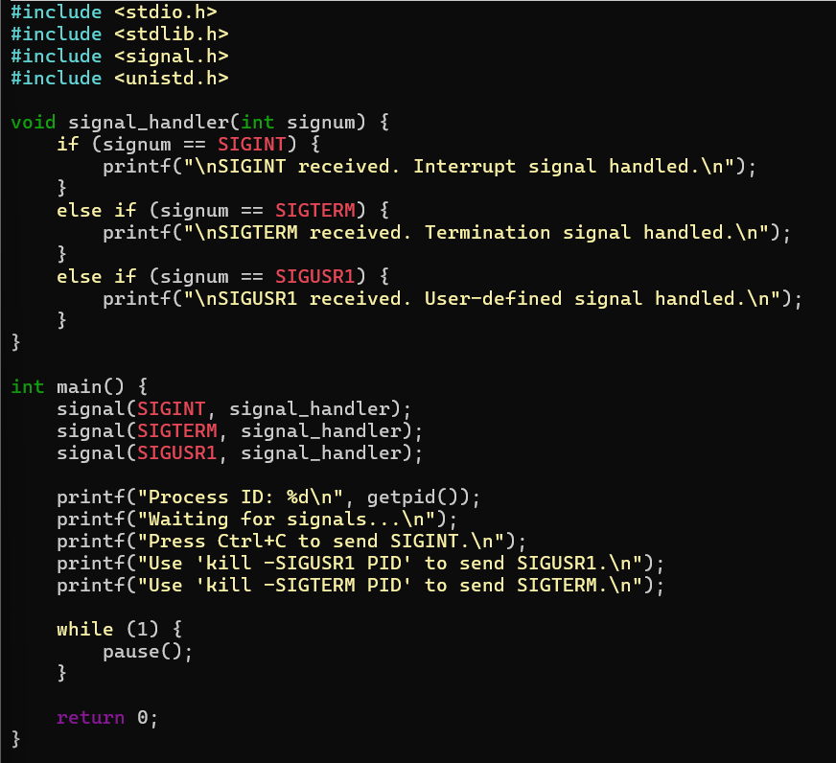
Output
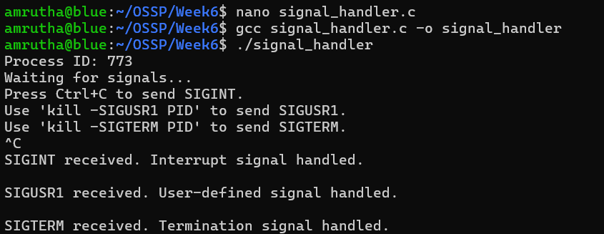
Observation
The program registers a signal handler for SIGINT, SIGTERM, and SIGUSR1. When any of these signals is delivered, the operating system asynchronously invokes the corresponding handler.
- SIGINT — normally generated using Ctrl+C.
- SIGTERM — requests termination of a process.
- SIGUSR1 — a user-defined signal that can be used for application-specific events.
The pause() system call keeps the process waiting until a signal is received.
Result
The POSIX signal handling program was successfully implemented. The program captured SIGINT, SIGTERM, and SIGUSR1 and demonstrated asynchronous event handling using signal handlers.

